Berk Sebit-11916039 || Mehmet Ali Özkaya-11952033

**SCOPE**

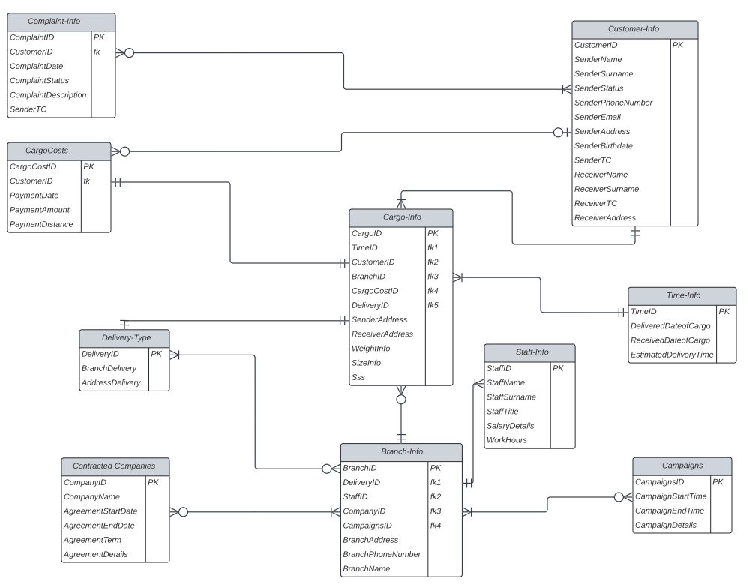**Database Design**

BM cargo database consists of 10 tables such as cargo information, branch information, customer information, etc. The entity relationships between some of these tables are as follows:

* We used zero or many symbol for the Cargo-Info table and one and only one for the Branch-Info table. Because each cargo can be associated with multiple branches (zero or many), and each branch can be associated with only one cargo (one and only one).
* We used one or many symbol for the Cargo-Info table and one and only one for the Customer-Info table. Because customers can have multiple shipments, but shipments cannot have more than one owner.
* We used one and only one symbol for both the Cargo-Info table and the CargoCosts table. Because each cargo has its own unique price.

We created our database from phpmyadmin. The BM cargo database consists of 10 tables, and we entered almost 2 data for each table.

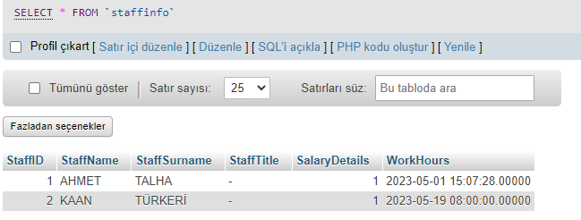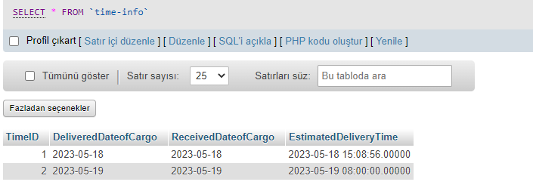(Database pictures)

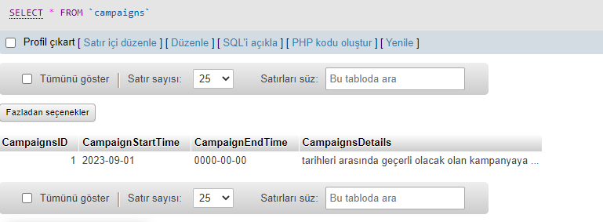

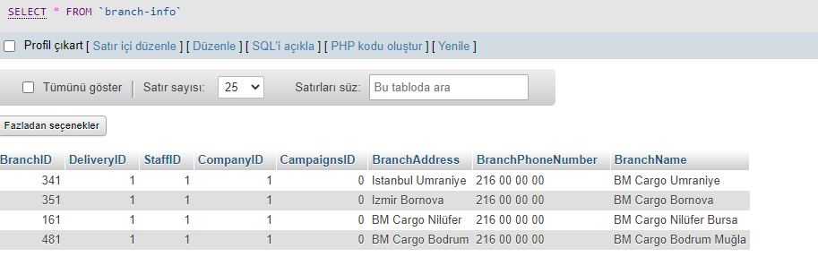

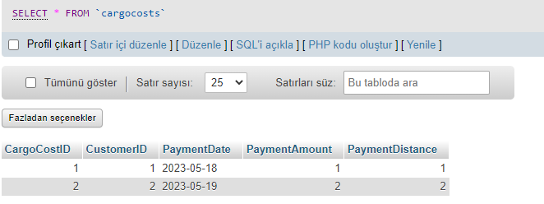

(Database query pictures)

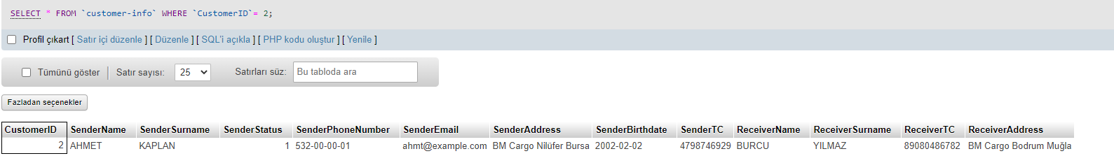

**User Interface Design & Database Queries**

